"Ariel" Ambulance Rescued!
Join the Ariel Ambulance Rescue Group
www.ArielAmbulance.org
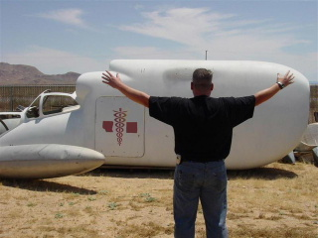

Firefly episode "Ariel" Earth-That-Was 2005 A.D.
Found in a scrap yard on Ariel Found in a scrap yard in the Mojave desert
Fixed up Will fix it up
Flown to Alliance hospital so our BDHs could... Will drive it around to...
Scan River's brain Assist Red Cross Blood Drives
Steal some medicine Promote Serenity
Ended up...??? Will rest in museums, travel to conventions

"Ariel" Ambulance Rescued!
Join the Ariel Ambulance Rescue Group
www.ArielAmbulance.org

Firefly episode "Ariel" Earth-That-Was 2005 A.D.
Found in a scrap yard on Ariel Found in a scrap yard in the Mojave desert
Fixed up Will fix it up
Flown to Alliance hospital so our BDHs could... Will drive it around to...
Scan River's brain Assist Red Cross Blood Drives
Steal some medicine Promote Serenity
Ended up...??? Will rest in museums, travel to conventions

